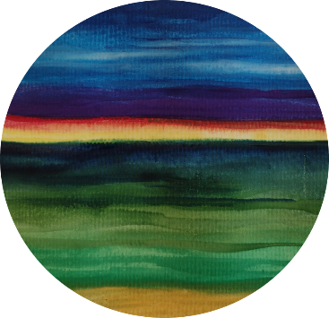

Washington State Federation of Garden Clubs

ANNUAL MEETING and FLOWER SHOW

June 10-13, 2024

“Our Extraordinary Earth”

Celebrating the natural beauty of our world

Workshops and Activities
Tuesday June 11, 2024

10:30 am – NOON
Extraordinary Birder with Christian Cooper
After entering your exhibits for the Flower Show, sit and relax while watching a video about unusual birds in El Yunque National Forest, Puerto Rico.

NOON – 2:00 pm Self-Guided Tour - Outdoor by Design, Bamboo Nursery
Address: 221 WA-3, Shelton, WA 98584 Phone: (360) 432-8493 outdoorsbydesign.com
Just 10 minutes from Little Creek Casino. Bamboo is one of those misunderstood (and sometimes misused) plants that many people admire for its beauty yet are afraid to have it in their landscape. The nursery was started in 2008 with the intent of making non-invasive bamboo available to homeowners, retail nurseries, and other landscape businesses in western Washington. Get creative with bamboo!

2:00 – 3:30 pm Sue Goetz Nurturing Herbs & Uses suegoetz.com
Make your peppermint foot soak and herbal facial with herbs from the garden. Hands on workshop. Come for a show and smell! Limited to 30 participants. (Sue will also be our keynote speaker for dinner!)

Wednesday June 12, 2024

9:00 – 10:00 am #1 Kokedama by Olympia Garden Club member, Jeff Johnson
10:00 – 11:00 am #2 Kokedama by Jeff Johnson
Kokedama (Japanese for "moss ball") is a style of potting up plants in a ball of moss and displaying them in a dish or suspended in the air. Make one to take home. Limited to 20 participants in each class.

11:00 am – NOON Corsage Workshop
WSFGC member Tory Bennett will lead participants to make a beautiful corsage. Limited to 30 participants.

2:00 – 4:00 pm Self-Guided Tours – great experiences await at these unique nurseries and gardens

Outdoors by Design, Bamboo Nursery (location & description above)

Lael’s Moon Garden Nursery
Address: 17813 Moon Road SW, Rochester Phone: (360) 273-9567 laelsmoongarden.com
Approximately 30 minutes from Little Creek Casino. "Plant Your Own Eden" Over 1000 varieties of ornamental trees, shrubs, edible landscape plants and perennials, selected to thrive in the Northwest. Unusual varieties and "good doers." (continued on next page)

Monarch Sculpture Gardens
Address: 8431 Waldrick Rd SE, Tenino Phone: (360) 264-2408 monarchsculpturegardens.org
Approximately 35 minutes from Little Creek Casino.
Contemporary Art Center and Sculpture Park is an outdoor art gallery located along the Chehalis
Western Trail near Tenino. Opened in 1998 by sculptor Myrna Orsini as "a gift to the
community," the 80-acre park features sculpture gardens. It is open to the public daily from
dawn to dusk.

2:00 – 4:00 pm Christine Dillinger, NGC Environmental Consultant and WSFGC member
Christine will narrate an interesting video, which was recently used in the online version of NGC Environmental School Course 1. Limited to 40 participants.

