Design a “Black Hills District of Garden Clubs” Logo and Win $50!
The Black Hills District of Garden Clubs doesn’t have a club logo. Here’s an opportunity to create a logo for our District that promotes who we are and what we do!
Calling all Black Hills District Garden Club Members!

Contest winner will receive $50!
- Design a logo for the Black Hills District of Garden Clubs and win $50!
- Design a logo that promotes our club’s purpose, values and community spirit with visual appeal using colors and shapes that represent nature and gardening.
- Create a simple but “colorful” design for display on our websites, newsletters, stationary, posters, business cards, etc. and that is recognizable and memorable.
Contest Instructions
  - Logo may be designed/submitted by an individual club member or by a garden club.
  - One $50 prize rewarded to winner.
  - Logo will be reviewed/selected by the BHD Board members.
  - Logo winner will be recognized in the Black Hills District “The Bugle” newsletter and the WSFGC Garden & Design magazine.
- Logo must include the words: Black Hills District of Garden Clubs
  - Do not put in a PDF format as editing will be required for the final image.
  - The larger the design (on 8.5 x 11 letterhead) the better to ensure image clarity.
  - Submit design electronically to Chris Hill, BHD Website Editor.
Email: chillnhill247@gmail.com
Timeline
  - Submit logo no later than January 9, 2026.
  - Final logo to be presented at our April 2026 General Meeting.
  - Questions? Contact Chris Hill, BHD Website Editor at email (above link).

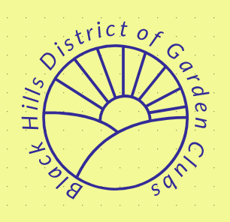
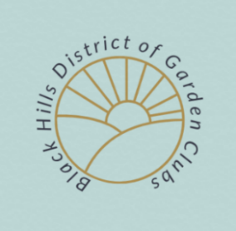
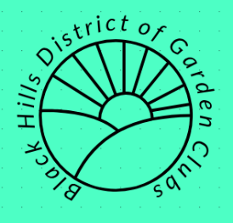
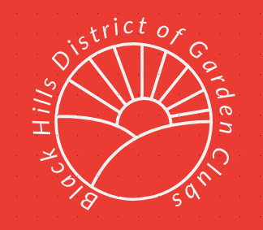
Here’s a simple idea for a logo!

