Both “A Little Bit of Magic” Sequim, November 12th, 2025.
WSFGC State Judges Council
The Washington State Judges Council held a flower show at the recent State Board Meeting in Sequim. To my knowledge, this was our first State Design Specialty Flower Show and it featured all Petite Designs. A Design Specialty Flower Show only displays designs and has no Horticulture Division. Similarly, Horticulture Specialty Flower Shows are an option to hold as well and display only Horticulture and no designs. Maybe we will host one of those next.
A huge Thank You to the Olympic Peninsula District members who worked tirelessly on this event. They had all that was needed in place to receive the entries, a beautiful Theme Staged Show Room and willing volunteers! Great job!
It takes a lot of people to prepare for and produce a flower show. Planning begins months beforehand: Rooms are reserved, Schedules are written and printed, Chairmen are procured, the event is publicized, and entrants are signed up. Best of all, once the show opens, it may even look like it was effortless, the illusion of all great social events.
Please enjoy the photos of the winning designs of this special event.
Co-chairman: Linda Maida & Debbie Spiller, WSFGC C0-State Judges Chairman
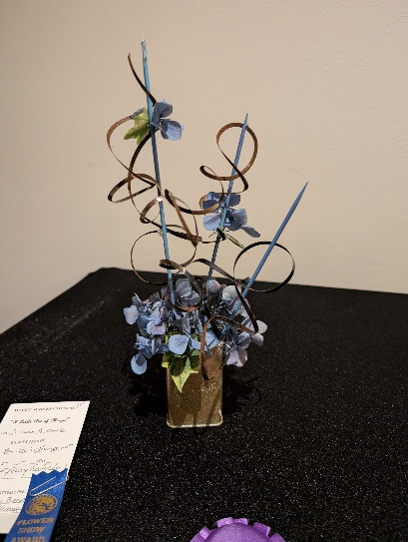 Class 6. “Now You See It, Now You Don’t”. 12” Transparency Design, Tory Bennett, Chinook District. Tory won a Blue ribbon and the NGC Designers Choice Section Award. Tory used hydrangea and ivy, both dried and achieved a very creative line.

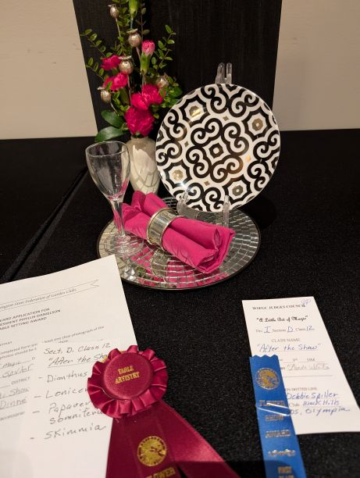Class 12. “After the Show” 12” Exhibition Table Setting. Debbie , Black Hills District, won the NGC Table Artistry Award and WSFGC Phyllis Danielson Table Setting Award. Debbie used Dried Painted Annual Poppy Seed Pods, Evergreen Honeysuckle and Mini Carnations in her design.
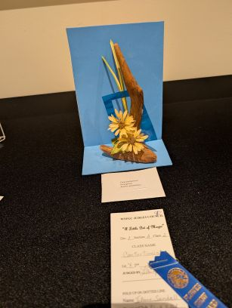 Class 2. “Contortionist” 8” Angular Design, JoAnne Sandell, Black Hills District, Blue Ribbon Winne. Her all dried plant materials included: Rudbeckia hirta, Miscanthus sinesis and Viburnum tinus..

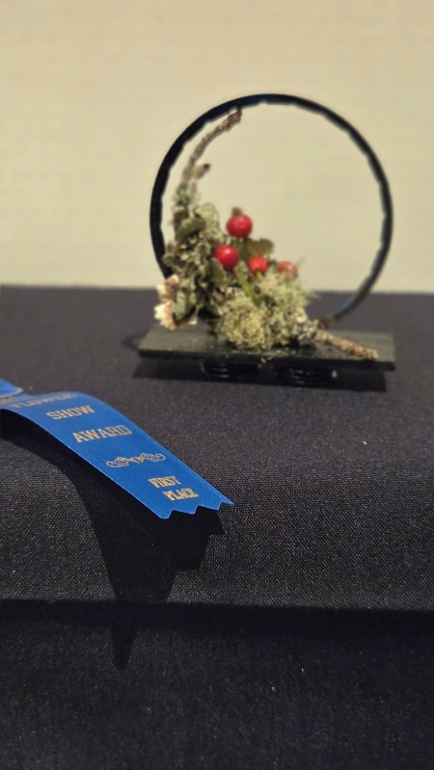
Class 4., “Center Stage”-Sherry Mathews, Hill & Dale District, won a Blue Ribbon on her design using a 3” hoop provided by the show committee. Sherry used a fir twig that had moss and lichen on it and rose hips.
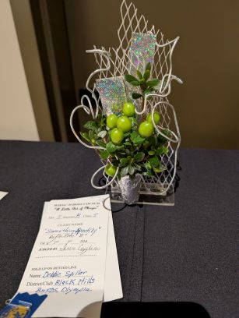 Class 5. “Something Sparkly” Debbie Spiller, Black Hills District, 8” Reflective Design, Blue Ribbon Winner. Debbie used Evergreen Azalea foliage and Hypericum berries.
“

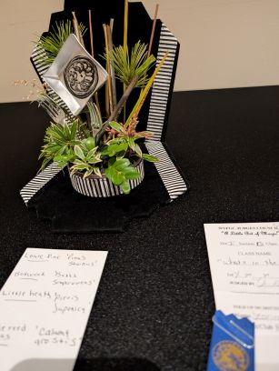Class 11. “What’s in the Hat?” 8” Exhibition Table Setting. A Blue Ribbon for Jeanine Faulkner, Hill N Dale District. Jeanine used Louie Pine, Boxwood and Pieris japonica for her plant materials.
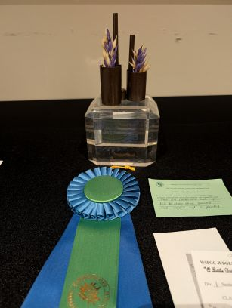 Class 1. “Master Illusion” 5” Spatial Thrust Design. Kathy Johnson of Hill N Dale District received a Red ribbon and the WSFGC Recycle Award. Her plant material was Avena sativa ‘Common Oat’. Her recycled items in the design included: Plastic pill bottles, a Chap stick lid and Plastic straws.

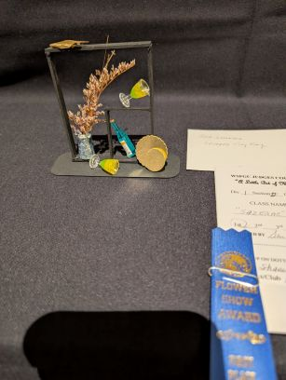 Class 10. ”Sarzerac” 5 Inch Exhibition Table for cocktails, Sharon McKissick, Black Hills District, Blue Ribbon Winner. A “Sarzerac” is a cocktail from a bygone era. Sharon used Sea Holly and Ting-ting, a rattan product.
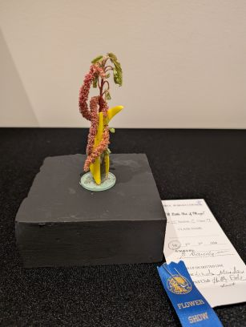 Class 7. “Sleight of Hand”. Linda Maida, Blue Ribbon Winner, Hill & Dale District. Linda used dried Amaranthus in her creative line design.
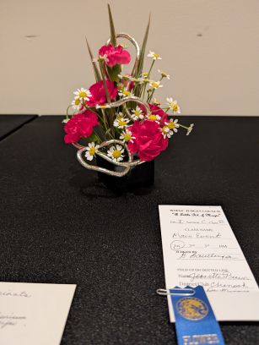

Class 8. “Main Event”, 8” A Creative Mass Design by Jeanette Pruin, Chinook District, Blue Ribbon Winner. I believe Jeanette used Dianthus-mini carnations, variegated draecena and an unknown petite Chrysanthemum variety in her design.
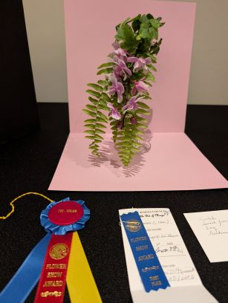
Class 9.” Something Up His Sleeve”, Cascade Design, Sharon McKissick, Black Hills District, NGC Tri Color Section Award Winner. Sharon used Orchid, sword fern, ivy, and gardenia leaves.
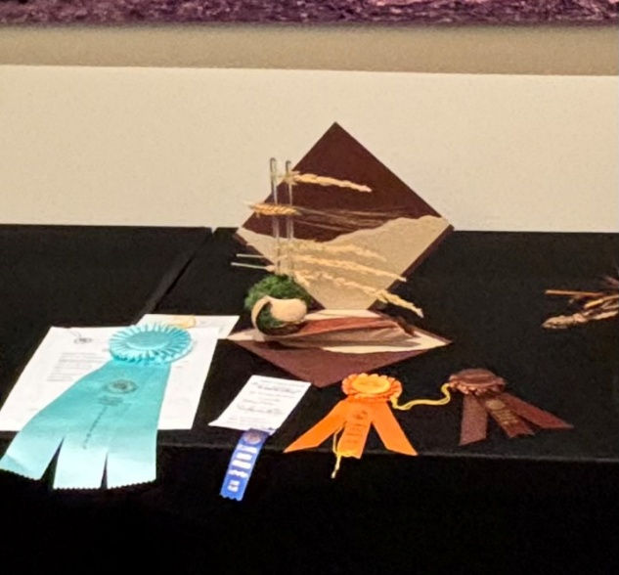 Class 3. “Floating Maiden” 12” Horizontal Line Design. Our Show Winner by Diane Franchini, Central District. Diane received the NGC Award of Distinction-all dried section award, the NGC Award of Design Excellence and the WSFGC Ellen Swenson Award. Diane used several unique pieces of plant material:
Phoenix dactylifera ‘Date Palm’ spathe
Brachychiton populneus ‘Australian Kunnajong’ Tree seed pod
Cladonia raroiferina ‘Reindeer moss, preserved
Calamgnostis Acatiform ‘Karl Forester Grass’ “Feather Reed’
Blackbeard wheat head

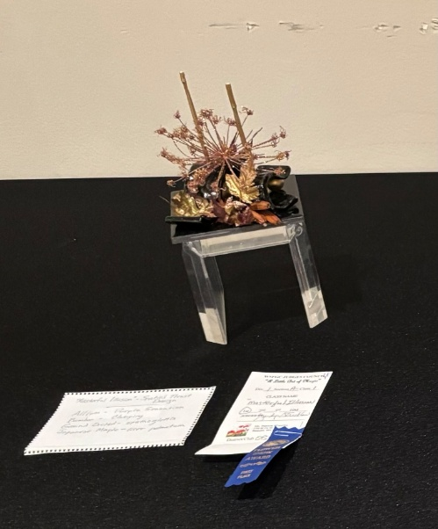Class 1 “Masterful Illusion”. Patty Wheatley, of the Olympic Peninsula District, Pt Angeles GC. She received a Blue Ribbon. She used Allium, Bamboo, Japanese Maple and Ground Orchid in her all-Dried Design.
It was a great show!
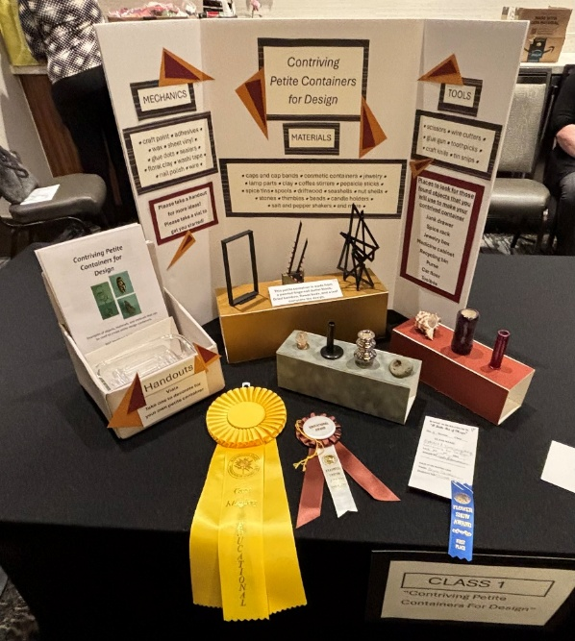
“Contriving Petite Containers for Design” was Brynn Tavasci’s winning Educational Exhibit. She was awarded the NGC Educational Award and the WSFGC Carol Klingberg Educational Award. Please notice that the Staging Panel in this display is on is also “petite” sized, as per NGC rules.

